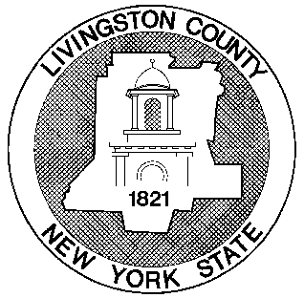

LIVINGSTON COUNTY HISTORIAN'S OFFICE
HOLLY WATSON, COUNTY HISTORIAN
5 Murray Hill Drive, Mount Morris, New York 14510
Phone: (585) 243-7955 | Email: Historian@co.livingston.ny.us
Website: LivingstonCounty.us/162/County-Historian

Collecting Craig Colony Stories

Contributor Agreement

Purpose
The era of Craig Colony, which officially ended over 30 years ago, is highly significant to local and state history and beyond.
With support and guidance from interested individuals formerly connected to Craig, the Livingston County Historian’s Office is facilitating a project to collect information about Craig Colony, and those who worked there, for historical documentation and research purposes. The materials collected will help ensure that the experiences and perspectives of Craig staff members will be preserved and a more comprehensive view of the institution is captured.
All information collected, including written responses, recorded interviews, digital and/or original photographs, and other ephemera, will be archived at the Livingston County Historian’s Office in Mt. Morris.
I understand that I will not receive any compensation in connection with my contribution.

I prefer to remain anonymous in any public use of this material by the Livingston County Historian’s Office:
(Circle one) YES NO

Signed: ___________________________________________ Date:___________________________
Contributor

Questionnaire

Full Name: ______________________________________________________________ Date: _____________________
Phone: __________________________________________Email: ____________________________________________
Start/end date of employment at Craig Colony: ___________________________________________________________

This is an outline only. Please attach extra sheets, type up on a computer, or contact the Livingston County Historian for other ways to tell your story.
- What were your work responsibilities at Craig?

- What were interactions and work relationships like with other staff members?

- If you interacted with clients/consumers, what were your interactions like?

- What are your impressions of consumer care at Craig, and how did care change over the time you worked there?

- Describe any other institutional changes and how they affected your work.

- In your experience, how did Craig impact the local economy and community? Did this change over time?

- Please feel free to share any other memories or perspectives! Ex. Notable characters, perceptions of Craig, particularly enjoyable or difficult times, etc.

- If you have photographs or other items related to Craig Colony, are you interested in donating copies or originals to the Livingston County Historian’s Office? If yes, the archives can accept photos and paper items into the permanent collection or digitize photographs and return the originals to you. If interested, we will contact you to discuss.
  - Yes, I want to donate original materials
  - Yes, I want to donate digital copies, but keep my originals
  - No, thank you

