Getting Your First Job:
A Guide to Youth Employment





& YOUTH BUREAU

Table of Contents
What to Think About Before Looking for a Job……………….….4
Legal Hours of Work and Availability……………………4
My Skills………………………..…………………………5
Age Requirements………………………………………………....8
12 Years Old………………………………………………8
14 & 15 Years Old………………………………………...8
16 & 17 Years Old………...…………………………..…14
What Papers Do I Need to Get a Job?………...……………….…19
Where to Find Job Openings………………………………….….21
Worksite Script: Phone Call or In-Person……………………….22
Filling Out an Application………………………………….……23
Interview Tips……………………………………………………28
Business Ideas for Youth……………………………...…………29
Helpful Links…………………………………………………….31
Local Employment Opportunities by Town…..…………………32
Keeping Your Job ……………………………………………….40
Track Your Applications ………………………………………...41

What to Think About Before Looking for a Job
When can I work? The times that you can work will affect what jobs you apply to. Think about the time commitments you already have. Do you play sports or join in any after school activities that may limit your time? Think about the employer’s business hours. How many hours can you legally work on a school day or weekend? See the charts below.
Work Hours: 14-15 Year Olds
School | Max Daily Hours | Max Weekly Hours | Max Weekly Days | Work Schedule
IN Session | 3-school day 8-other day | 18 | 6 | 7am-7pm
OUT Session | 8 - any day | 40 | 6 | 7am-9pm
Work Hours: 16-17 Year Olds
School | Max Daily Hours | Max Weekly Hours | Max Weekly Days | Work Schedule
IN Session | 4-school day (M-Th) 8- (F-Sun; Hol) | 28 | 6 | 6am-10pm
OUT Session | 8 - any day | 48 | 6 | 6am-midnight

What do I know how to do? You already have skills that employers are looking for, so think about what you know how to do. What do you practice every day at school? It is okay if you do not have technical skills because the employer will train you on the job. On the following page is a short checklist to help you narrow down your skills.
Step 1: next to each skill you have.
Step 2: Circle your top 10.
Step 3: Number your top 3.

Able to coordinate
Able to lead
Accept Direction
Adaptable
Ambitious
Businesslike
Calm
Capable
Cautious
Good Talker
Confident
Considerate
Decisive
Dependable
Determined
Direct
Discreet
Efficient
Enthusiastic
Firm
Flexible
Friendly
Good Listener
Good-natured
Hard worker
Helpful
Honest
Humble
Imaginative
Independent
Intelligent
Intuitive
Logical
Mature
Motivated
Optimistic
Organized
Patient
Polite
Precise
Problem solver
Productive
Punctual
Realistic
Reliable
Resourceful
Responsible
Self-confident
Sense of Humor
Sympathetic
Tactful
Teachable
Thorough
Timely
Trustworthy
Verbal


How will I get to work? Can someone drive you? Do you have access to a car? Can you walk or bike there? Do you have a friend working at the same place who can give you a ride?

What can I do at my age? New York State has minimum age requirements for certain activities. On the following pages is a list of approved work activities and the minimum age you must be to do them.
Age Requirements

12 Years Old
- Hand harvest fruits and vegetables

14 & 15 Years Old – The previous task and…
Animal Care
- Capture and tag wildlife
- Clean fish tanks and feed fish
- Clean animal kennels
- Clean horse barns
- Feed animals
- Handle, feed and assist in care of laboratory animals
- Walk animals

Building Maintenance

- Change light bulbs from ground or floor level only
- Clean walls, windows, screens inside, from floor level
- Clean freezers and refrigerators (from outside)
- Clean vacant apartments
- Clean lavatories
- Clean garages, attics and basements
- Clean kitchen areas but not kitchen machines
- Clean locker rooms
- Dust furniture and fixtures
- Load garbage into a dumpster

Building Maintenance (Continued)

- Move furniture (but not as a helper on a motor vehicle)
- Operate dry or wet vacuum cleaner
- Operate floor waxer
- Polish ornamental brasses and architectural hardware inside, from floor level
- Remove fire hazards from houses and vacant lots
- Remove carpet from buildings
- Replenish supplies in lavatories
- Work on a stepstool

Childcare

- Assist children in swimming pool
- Babysit children in connection with a trade, business or service
- Change diapers
- Counselor in a day camp for children
- Feed children
- Groom other persons
- Help prepare children for medical procedures with play therapy
- Help counselor supervise children at pool or playground
- Read books to children
- Sort soiled clothing and linens
- Supervise children
- Supervise children using bathrooms

Childcare (Continued)

- Supervise children’s sports activity
- Teach crafts to children
- Tutor youth or adults

Food Service

- Clean kitchen areas but not kitchen machines
- Pack meals to be distributed
- Prepare food without cooking
- Wash dishes by hand
- Cook on electric or gas grill with no open flame
- Cook with deep fryer equipped with and using a device for automatically raising and lowering basket

Gardening & Landscaping

- Apply herbicides or fertilizer to plants, lawns, shrubs, or other area
- Clear brush with hand tools
- Clear brush along streams
- General gardening without power machines
- Haul seaweed out of lake with rakes
- Lawn edging with hand tools
- Mow lawns with a non-power push mower
- Plant and maintain vegetable gardens
- Plant seedlings and other plants
- Roll lawns with hand roller

Gardening & Landscaping (Continued)

- Trim shrubs with hand clippers
- Water lawns or garden

Medical

- Assemble patient meals on a belt line
- Assist physical therapist with patient ambulation
- Assist in a medical laboratory
- Deliver materials to labs
- Feed handicapped persons
- Load film into an X-ray machine (developer)
- Sort and file medical records
- Transport person in a wheelchair
- Transport food carts in hospital

Nursing Homes

- Assist in the care of residents
- Assist patients in occupational therapy
- Deliver mail in nursing home
- Distribute clean laundry
- Feed handicapped persons
- Groom other persons
- Make beds in nursing home
- Sort soiled clothing and linens
- Straighten rooms and closets
- Supervise resident smokers

Nursing Homes (Continued)

- Take residents for a walk
- Transport person in a wheelchair

Office Work

- Answer phones
- Be part of a guided tour in an industrial complex or educational facility
- Computer operation
- Data input to computer
- File or staple in an office
- General office work with/without office machines
- Open and sort mail
- Operate paper shredder
- Receive and count money
- Shelve books in library from floor level only
- Stuff envelopes
- Take motor vehicle license photographs
- Take membership photos
- Wash library books
- Wash desks
- Work in mail room

Recreation

- Check entrance and parking stickers at park
- Collect fees and issue stickers to park users
- Ride a roller coaster as a recreational aid
- Maintain golf course without power equipment

Recreation (Continued)

- Stamp park users’ hands
- Assist children in swimming pool
- Check towels at swimming pools
- Clean and pick up around swimming pool
- Help counselor supervise children at pool or playground
- Inspect hands and feet of swimmers
- Log participants in at swimming pool
- Monitor swimming pool locker rooms
- Teach swimming

Vehicle Maintenance

- Wash fire trucks
- Wash school buses in bus garage or parking lot
- Wash motor vehicle indoors or outdoors
- Wash and clean garbage trucks

Other

- Accompany social worker making home visits
- Be transported by vehicle to work locations
- Collect water and sewage samples
- Lift heavy objects
- Pick up debris from vacant lots or roadways
- Run errands
- Split firewood by hand
- Work in storeroom

15 Years Old – All of the previous tasks and…
- Lifeguard at a swimming pool

16 Years Old -- All of the previous tasks and…

Building Maintenance

- Apply water stain to fences from ground level, but not in connection with a construction site
- Change light bulbs from a ladder
- Clean walls, windows, screens, outside, from ground level
- Clean floors in bus garage
- Clean outside of a building from ground level
- Operate power floor buffer
- Paint bleachers from the ground
- Paint bleachers above ground from the bleacher itself
- Paint building interior or exterior from ground level, signs, garage doors, picnic tables, handrails, fences, parking lot lines, playground equipment, park benches
- Polish ornamental brasses and architectural hardware on the exterior of a building, from ground level

Building Maintenance (Continued)

- Sand desktops by hand
- Strip wax from floors

- Sweep up sawdust in a carpentry shop
- Sweep floors in motor vehicle garages
- Use solvents and cleaning chemicals
- Wash windows from ground level
- Work in or about a boiler or engine room
Food Service

- Cook using rotisserie, broiler, pressurized equipment, devices that operate at extremely high temperatures, or deep fryer lacking a mechanism for automatically raising and lowering basket
- Operate food processor in a kitchen
- Wash dishes in dishwasher

Gardening & Landscaping

- Apply pesticides to plants, lawns, shrubs or buildings
- Clear brush with with a string line or brush blade
- Lawn edging with a power edger
- Mow lawns with power-driven push or riding mower

Gardening & Landscaping (Continued)

- Operate power weed trimmer or weed whacker
- Trim shrubs with power trimmer, from ground level
- Roll lawns with power roller or with tractor-pulled roller
- Trim trees not near power lines, from ground level
Medical

- Assist in a medical laboratory if occupation involves washing, cutting or slicing machinery
- Wash and sterilize glassware in biology laboratory
- Work in a mental health facility

Office Work

- Operate manual paper cutter
- Operate letter folder

Recreation

- Maintain golf course with power equipment and/or use golf cart
- Lifeguard in a natural environment like a lake, pond, river, stream
- Swimming pool cleaning and maintenance

Vehicle Maintenance & Operation

- Motor vehicle maintenance without hoists, lifting apparatus, pits or racks
- Operate power-driven machinery other than office equipment, vacuum cleaners and floor waxers
- Paint snowplow blades
- Wash fire trucks, if done in conjunction with a structure where truck repairs are done.
- Wash school buses in bus garage where repairs are done or parking lot with power-driven washing machines
- Wash motor vehicles indoors or outdoors where repairs are done or with power-driven washing machine
- Wash and clean garbage trucks where repairs are done or with power-driven washing machine
- Work in a motor vehicle repair facility

Other

- Iron and press clothing and linens
- Launder clothing and linens
- Load or unload a conveyor belt
- Operate hot name stamping machine in laundry
Other (Continued)

- Paint objects not part of a building

- Sort glass, metal, paper & plastic refuse at a disposal site

17 Years Old – All of the previous tasks and…

- Operate auto or truck that does not exceed 6,000 lbs. loaded, during daylight hours, with valid license and no moving violations. Youth has successfully completed driver education course, within 30-mile radius of primary place of employment. Driving is only occasional and incidental to employment. Driving does not involve towing, route deliveries, or urgent, time sensitive deliveries or the transporting of more than 3 passengers.

What Papers Do I Need to Get a Job?
You will need documents that establish both identity and employment authorization. Most people will provide a Birth Certificate or Social Security Card: An original of one or the other. No copies. If you do not have an original, see Helpful Links section for instructions to get a replacement. That section also includes a link to see the full list of approved documents in order to establish employment authorization.

Work Permit: If you are under 18, you need a work permit (also called working papers). Before you start applying for jobs ask your school for an application. In order to get a work permit you need to have had a physical exam in the last 12 months and proof of your age (birth certificate, driver license, state issued ID, school record or passport). You will also need your parent or guardian’s signature on the application. Go to http://www.p12.nysed.gov/sss/pps/workingpapers/ for more information.
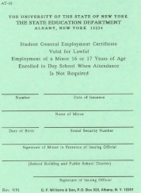
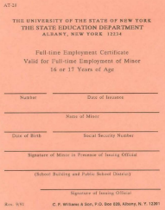
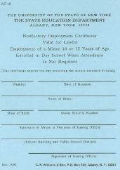
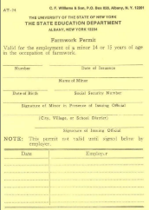
By Age
16/17 GREEN:

14/15 BLUE:

Full-Time SALMON:
14/15 FARM Permit:

Where to Find Job Openings
Online: Employers will post job openings online. Try searching snagajob.com, indeed.com, and gvpennysaver.com
Network: Talk to people you know. Your family or friends may know of opportunities that have not been posted anywhere and having someone to vouch for you may help persuade an employer to hire you.
Keep your eyes open: Keep an eye out as you are walking or driving around town for Help Wanted signs in local businesses. If you see any that you are interested in, go inside to introduce yourself, and ask about the opening. Go back later if it is busy or the manager is unavailable.



Worksite Script: Phone Call or In-Person
Use these scripts as a guide when you call or visit a business to ask about job openings.

Phone Script
- Hello, my name is __________.
- I’m calling about the (job title) opening.
- Can I talk to (contact person or the manager) please? Thank you.
- Introduce yourself again if you are transferred to another person.
- I’d like to learn more about the (job title) position you have posted.
- If they say that the position is still open, ask a few questions
  - Is there an application that I can fill out?
  - Will you hire a high school student under 18?
  - Is there a time I can come in for an interview?
- Thank you for your time.

In-Person Script

- Hello, my name is __________.
- I’m here to ask if you have any job openings.
- Is there a manager that I can speak to?
- Introduce yourself again if the manager is available.
- I’m interested in the (job title) position.
- If they say that the position is still open, ask a few questions
  - Is there an application that I can fill out?
  - Will you hire a high school student under 18?
  - Can I be scheduled for an interview?
- Thank you for your time.

Filling Out an Application
Most employers will have an application for you to fill out (either online or on paper). Do not be surprised if a manager asks you to fill out an online application even if you meet with them in person. Here are some tips that will help you with your applications.
- Have all your information in front of you before starting.
- Prepare a generic application ahead of time to make it easier and quicker.
- Be patient. Applications are long and may ask questions that you do not understand or have a quick answer to.
- Ask someone to help you. Ask a parent, guidance counselor, or an adult for help.
- Don’t leave anything blank. Write N/A on sections that do not apply to you to show that you read the questions (plus most online applications will not let you leave sections blank).
- Answer questions honestly. Later on, you may be fired if your employer finds you lied.
- Double-check your answers before handing it in.
- Print neatly if you are filling out a paper application.
- Memorize your social security number.
- References: Most jobs ask you to give them the contact information for 3 people who know you. You can use coaches, teachers, or people who you have done work for like lawn mowing or babysitting, or other adults who know you well. Ask for permission to use them as a reference. Do not use family members as references. You will need to provide their name, phone number, email, and your relationship to them.

Example of a Good Application
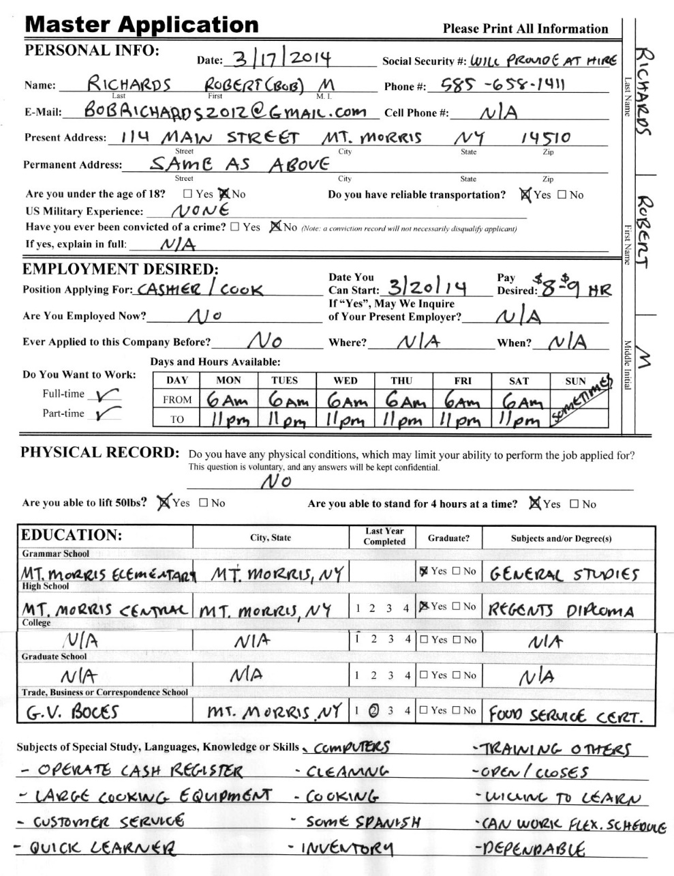

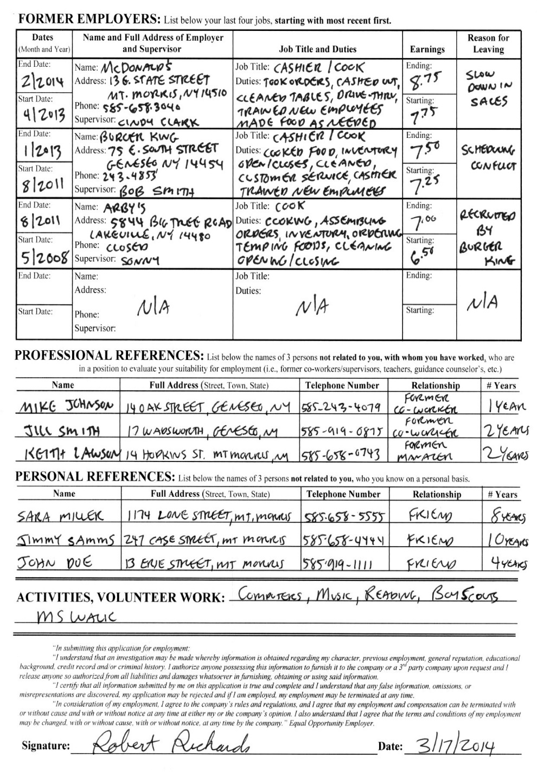
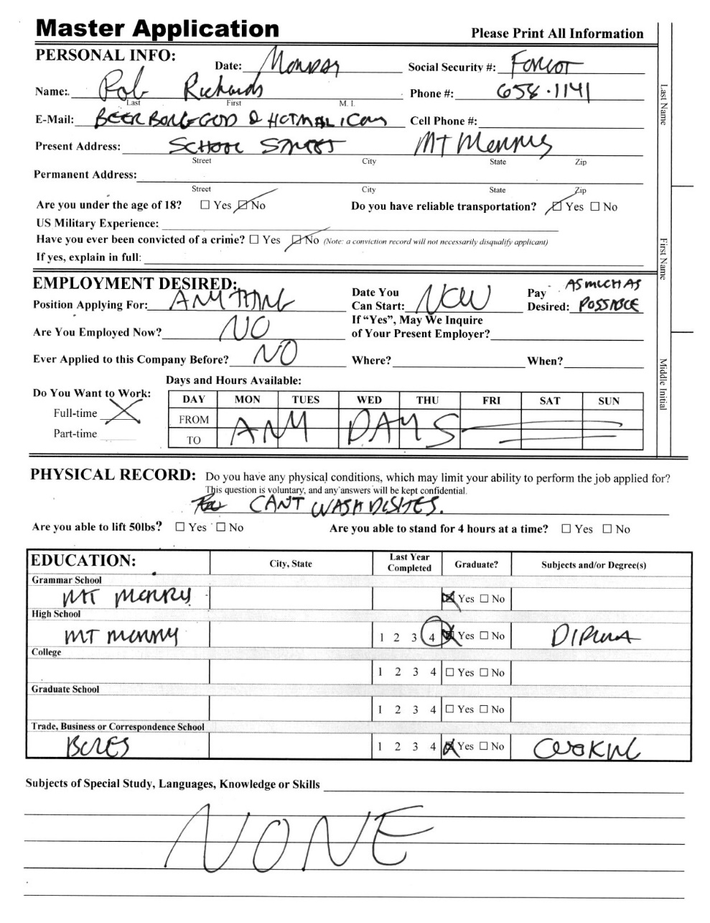
Example of a Bad Application

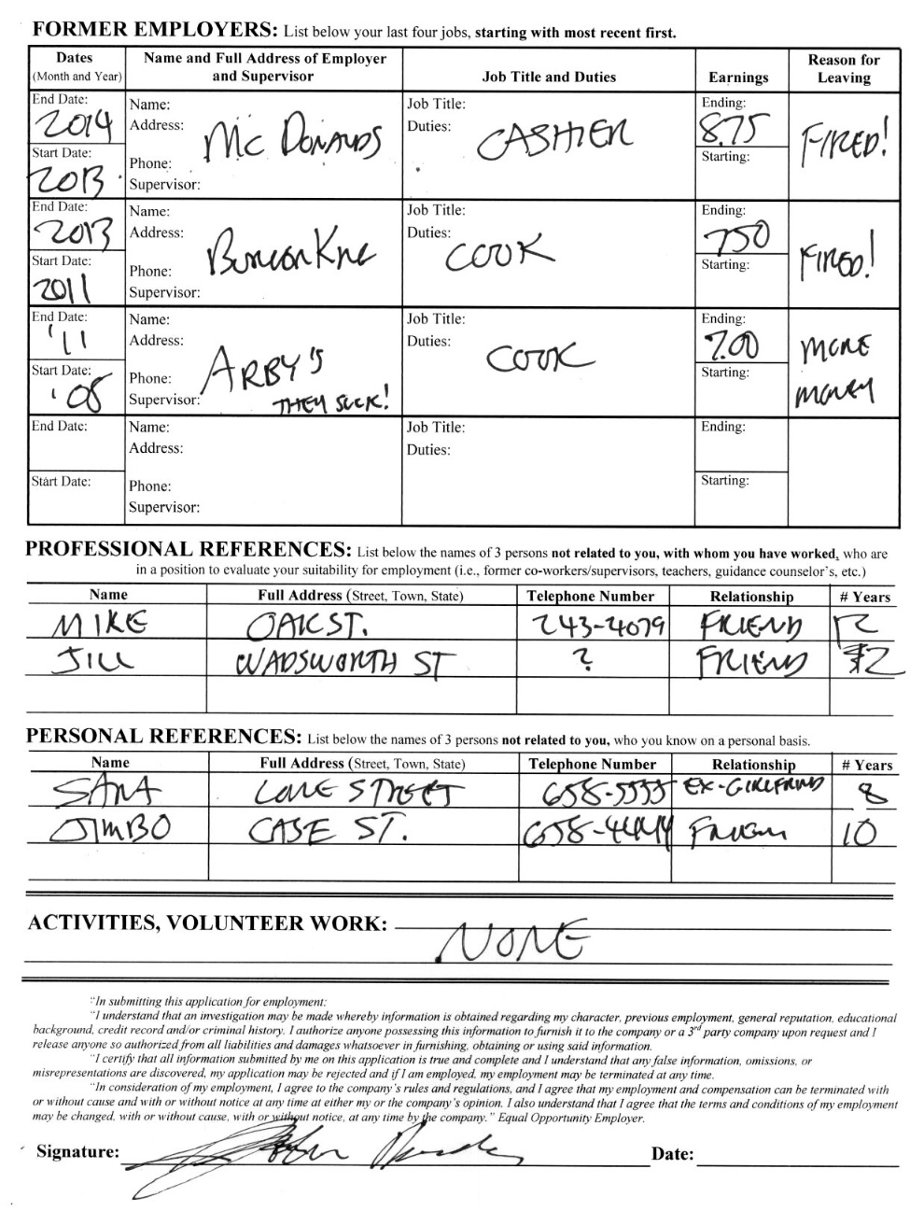
Interview Tips
- Dress nice by wearing clean clothes without any holes in them.
- Go alone. Do not bring your friends or parent in with you.
- Bring contact information for your references.
- Research the company beforehand.
- Prepare questions to ask: What are typical job duties? What are the hours?
- Practice these 3 tough questions ahead of time. In fact, write down your answers to help you memorize.
  - “Tell me about yourself. “ Talk about your work or school experience as it relates to the position you are applying. Look back at your top 10 skills and build your response around them.
  - “Why should I hire you?” Talk about any of the 10 skills you did not mention already.
  - “What are your weaknesses?” Talk about this as an area of improvement. Be sure to say what you are doing to get better at it.



Business Ideas for Youth
Start your own business or freelance instead. Below is a list of potential business ideas.

- Baby-sitting service
- Bicycle repair
- Birthday party coordinator
- Breakfast delivery to office workers
- Build and sell computers
- Bulk mailing service
- Calligraphy
- Car washing
- Catering
- Clean awnings
- Clean boats
- Clean vacant lots
- Cleaning services (home and office)
- Coach/teach/
tutor
- Sell crafts or creative services
- Sell baked goods/candy
- Sell secondhand/
vintage clothing
- Deliver papers
- Delivery service
- Distributing flyers
- DJ
- Dog walking
- Errand Services
- Exercise instructor
/personal trainer
- Graffiti removal
- House painting
- Ironing service
- Home organization
- Laundry service
- Lawn/garden care
- Meal delivery
- Office organizer
- Painting addresses on mailboxes
- Painting/
refinishing furniture
- Performing/
entertaining
- Personal shopper
- Pet care
- Photography/
videotaping
- Plant care
- Selling novelties

Business Ideas for Youth (Continued)

- Selling T-shirts
- Shovel snow
- Small home repairs/
maintenance
- Software installation
- Songwriting
- Sweep sidewalks
- Translating
- Umpire or referee
- Web site design



Helpful Links
Birth Certificates: If you do not have your original birth certificate, you can get another one in the town or village in which you were born or through New York State Vital Records.
- Born at Noyes Hospital: Birth Certificate Application (PDF) (fee is $10)
- Born in New York State: https://www.health.ny.gov/vital_records/birth.htm (fee is $30)
Full List of Acceptable Documents for Employment: https://www.uscis.gov/sites/default/files/document/forms/i-9-paper-version.pdf
Livingston County Workforce Development: The creators of this guide! We run the Summer Youth Employment Program. Find out more in our 24 & Under Services section https://www.livingstoncounty.us/570/24-Under-Services
NYS Department of Labor Youth Page: This link provides up to date information about work restrictions as well as helpful information for finding employment. https://dol.ny.gov/youth
Social Security Card: Apply to get a replacement card https://www.ssa.gov/forms/ss-5.pdf
Work Permit Application: http://www.p12.nysed.gov/sss/documents/AT17-FillableMay21.pdf
Local Employment Opportunities by Town
Avon:
The Avon Inn
- Ready to hire ages 16+
- 55. East Main St.
- (585) 226-8181
- www.avoninnny.com
Avon Park Theater
- Ready to hire ages 16+
- 71 Genesee St.
- bookings@avonparktheater.com
- https://www.avonparktheater.com/
Monroe Industries
- Ready to hire under 18
- 5611 Tec Drive
- 585-226-8230
- https://www.monroeind.com/
Partyman Catering
- Ready to hire ages 14+
- 1515 West Henrietta Road
- (585) 438-4321
- https://partymancatering.com/

Avon (Continued):
Pride & Joy Child Care
- Ready to hire ages 16+
- 1665 Interstate Drive
- (585) 226-6110
- https://www.pj-childcare.com/
Caledonia:
Angry Rooster Deli
- Ready to hire ages 16+
- 3178 State Street
- (585) 294-5208
- https://www.facebook.com/angryroosterdeli
Caledonia Diesel
- Ready to hire under 18
- 2905 Simpson Rd
- (585) 538-4395
- https://www.caledoniadiesel.com/en4/index.php?
Gigglin’ Pig
- Ready to hire under 18
- 3404 Caledonia Avon Rd.
- (585) 538-4099
- https://www.gigglinpig.com/
The Cozy Kitchen
- Ready to hire under 18
- 3103 Main Street
- (585) 538-2770
- https://www.cozy.kitchen/

Caledonia (Continued):
Caledonia Village Inn
- Ready to hire under 18
- 3137 Main Street
- 585-294-5130
- https://caledoniavillageinn.com/
Dansville:
Amanda’s Native Garden
- Ready to hire under 18
- 8030 Story Road
- (585) 750-6288
- www.amandasnativeplants.com
Angie’s Ice Cream Shoppe
- Ready to hire ages 16+
- 172 Main Street
- (585) 204-4123
- https://www.iloveangies.com/
Mill Creek Optical
- Ready to hire ages 16+
- 205 Main Street
- (585) 335-9490
- https://www.millcreekoptical.com/
Scovill’s Grill
- Ready to hire ages 16+
- 60 Red Jacket St.
- (585) 335-2601
- https://www.scovillsgrill.com/
Dansville (Continued):
Stony Brook State Park
- Ready to hire ages 15+
- https://statejobs.ny.gov/index.cfm
- https://parks.ny.gov/documents/employment/lifeguards/FillableUpdatedParksEmployeeApplicationS1000Part1.pdf
Tony’s Pizzeria
- Ready to hire ages 16+
- 140 Main St.
- (585) 335-8984
- http://www.thebestpizzaindansville.com/
Geneseo:
Cricket’s Coffee
- Ready to hire ages 16+
- 53 Main Street
- (585) 245-8984
- https://www.cricketscoffee.com/
Deer Run Winery
- Ready to hire 16+
- 3772 West Lake Road
- (585) 346-0850
- https://www.deerrunwinery.com/

Geneseo (Continued):
Rochester Theater Management—Geneseo Theaters
- Ready to hire 16+
- 4180 Lakeville Road
- (585) 243-4062
- https://rochestertheatermanagement.com/geneseo-theaters/
WeStandStrong Staffing
- Ready to hire under 18
- (585) 237-6143
- https://www.wssstaffing.com/
Lakeville:
Little Lake Brewing
- Ready to hire 16+
- 5857 Big Tree Rd.
- (585) 572-3005 or littlelakebrewing@gmail.com
- Get paper applications in person or use this link to download an application to complete and bring in.
- https://www.littlelakebrewing.com/
- Hiring for Cashier, Kitchen Laborer (cleaning, washing dishes, restocking, food prep, stocking inventory, general help in any area)
- Hiring Contact: Robbin Carll

Lima:
Jonny B’s Custom BBQ
- Ready to hire 14+
- 1883 Rochester St.
- (585) 582-7675
- https://www.jonnybscustombbq.com/
Lima Veterinary Center
- Ready to hire 16+
- 2089 Lake Avenue,
- (585) 582-3131
- https://limaveterinarycenter.com/contact.html
Livonia:
Fire Creek Farms
- Ready to hire 16+
- 3450 Plank Road
- (585) 233-9856
- https://www.thefirecreekfarms.com/
West’s Shurfine
- Ready to hire ages 14+
- 1 Main Street
- (585) 346-3023
- https://www.westsshurfine.com/

Mt Morris:
Harding’s Furniture & Mattress
- Ready to hire ages 16+
- 27 N. Main Street
- (585) 658-2234
- https://www.hardingsfurniture.com/index.html
Letchworth State Park
- Ready to hire ages 15+
- https://statejobs.ny.gov/index.cfm
- https://parks.ny.gov/documents/employment/lifeguards/FillableUpdatedParksEmployeeApplicationS1000Part1.pdf
Nunda:
Nunda Lumber & Hardware, Inc.
- Ready to hire ages 16+
- 11 S State St.
- (585) 990-2181
- https://www.nundalumberandhardware.com/
Wilcox Chiropractic
- Ready to hire ages 16+
- 18 South State Street,
- (585) 468-3440
- https://docwilcox.com/

Springwater:
All Western Evergreen Nursery & Christmas Tree Farm
- Ready to hire ages 14+
- 6840 Liberty Pole Rd
- (585) 669-2659
- http://www.allwesterntrees.com/

You got the job! Now What?!



Congratulations! You might think the hard work is over now that you got the job but it has just begun. Now you need to focus on keeping the job.
Things to ask before you start the job.
- Where do I report to on my first day?
- Is there a different entrance for employees?
- Who do I ask for when I get there?
- What is the dress code?
- Will I get a meal break?
At a minimum, remember this advice:
Early is on time.
On time is late.
Late is unacceptable.
What do I do when things happen? Expect the unexpected because anything can happen and it probably will.
Absences: Personal issues will come up which require you to miss work. You should plan to schedule appointments before and after your shift whenever possible. If you know that you will be absent, inform your supervisor in advance. If you do not have advanced notice that you will be out of work, you must call your supervisor as soon as you know. Missing work regardless of why can affect your employment.
Lateness: If you cannot report to work on time, call your supervisor immediately to apologize and let them know you will be late and tell them when they can expect you to be at work. Lateness regardless of why can affect your employment.
Accidents on the Job: If you have an accident on the job, follow the employers policy and tell your supervisor immediately so they can get you medical attention.
Quitting: If you are thinking about quitting your job because of a problem, contact your supervisor. Maybe things can be worked out. If you still feel you must quit, you need to give your supervisor at least two weeks’ notice.
Application Tracking

Date | Company | Position | Contact Person | Phone Number | Notes

