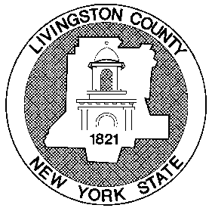
LIVINGSTON COUNTY PROBATION DEPARTMENT
Livingston County Government Center
6 Court Street - Room 101
Geneseo, N.Y. 14454-1043
585-243-7190
Fax 585-243-7169

Lynne C. Mignemi Jason G. Varno
Probation Director Elizabeth M. Laney
Probation Supervisors
Request for Information
Date of Request: Submitted by: Phone In Person USPS email (probation@co.livingston.ny.us)
Name: DOB: Phone Number:
If you have been known by any other name, please list:
Current Address: email address:

___________________________________________________________________________________
Offense(s) for which you need information:
- Date: Court: Conviction:
Sentence:
- Date: Court: Conviction:
Sentence:
___________________________________________________________________________________
Records Requested:
Verification of Probation Termination for: DMV
Other:
Verification of Financial Obligations Paid in Full
Other:

